Form 2
Revised: 2015
For Use by researchers
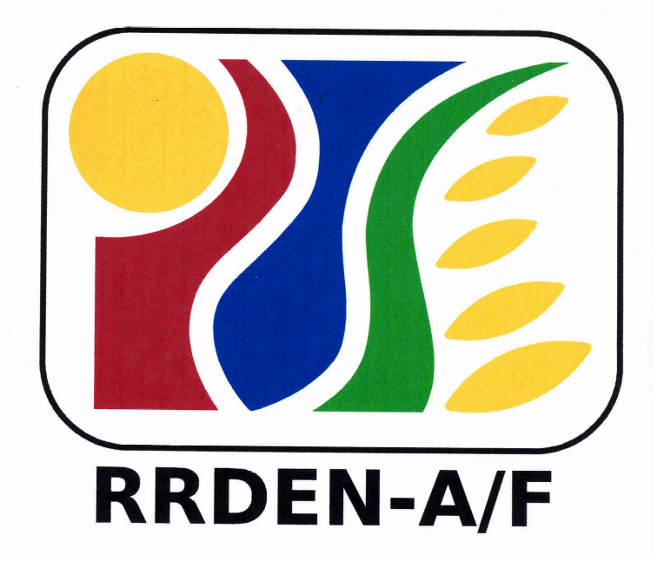
RRDEN and ViCARP
CY ____

Inter-Agency RDE Review

(Agriculture and Fisheries, Environment and Natural Resources)

REPORT FORMAT

For Completed

I. Basic Information (1 page)
Program/Project Title
Study Title
Researche(s)
Designation
Implementing Agency(ies)
Cooperating Agency(ies)
Funding Agency(ies)
Budget
Amount (per release)
PS
MOE
CO
Total Amount of Release
Expenditure(s)
Year
Total Expenditure(s)
Duration of the study:
Acknowledgement (1 page)
Abstract (another page)
II. Technical Description
Rationale
Objectives
III. Review of Literature
IV. Methodology
V. Results and Discussion (please identify & briefly describe the technology/significant info. generated)
VI. Summary, Conclusion and Recommendation
VII. Literature Cited
VIII. Appendices
IX. Documentation (pictures, knowledge product)

For On-going
I. Basic Information (1 page)
Program/Project Title
Study Title
Researcher(s)
Designation
Implementing Agency(ies)
Cooperating Agency(ies)
Funding Agency(ies)
Budget
Amount (per release)
PS
MOE
CO
Total Amount of Release
Expenditure(s)
Year
Total Expenditure(s)
Duration of the study:
Project Location
Executive Summary (another page)
II. Technical Description
Rationale
Objectives
III. Review of Literature (optional for extension)
IV. Methodology
IV. Results and Discussion (please identify and briefly describe the technology/significant info. generated
V. Literature Cited

