Form 3
Revised: 2015
For Use by researchers

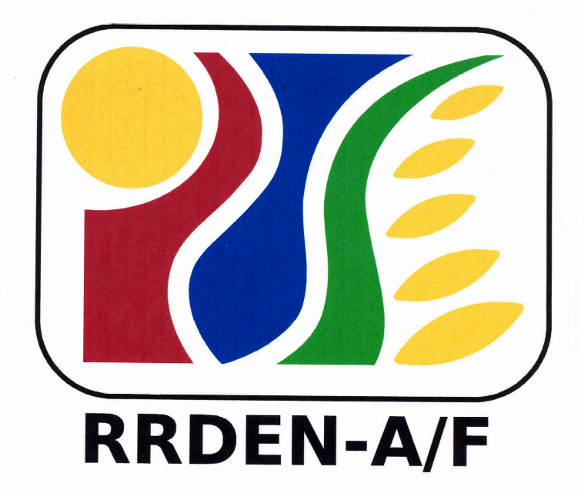
RRDEN and ViCARP
CY ____

Regional RDE Symposium

(Agriculture and Fisheries, Environment and Natural Resources)

REPORT FORMAT

For Research and Development Category

Program/Project Title (Cover Page)
Author/s (Cover Page)
Abstract (another page, not more that 300 words)
Introduction (Rationale, State of the Art, Analysis of the Problem)
Conceptual Framework (for social science research)
Objectives
Materials and Methods
Results and Discussion (include and briefly describe the technology/significant info. generated)
Summary and Conclusion
Implications and Recommendations
Literature Cited
Acknowledgement (1 page)

For the Extension Category
Program/Project Title (Cover Page)
Author/s (Cover Page)
Abstract (another page, not more that 300 words)
Introduction (Background of the project/service, why it was deemed important, unique strategy/methodology used, significant contributions to knowledge, socio-economic upliftment, environmental improvement, etc.)
Theoretical Framework (for social science research)
Objectives
Approaches, Strategies, and Methods
Results/Highlights/Accomplishments
Summary and Conclusion
Implications and Recommendations
Acknowledgement (1 page)

