Form 6A
Revised: 2015
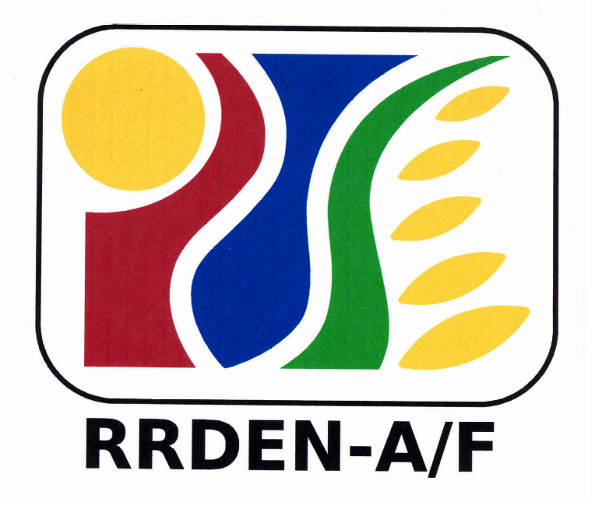
For Use of Evaluators
RRDEN and ViCARP
CY ___

Inter-Agency RDE Reviews
(Agriculture and Fisheries, Environment and Natural Resources)

Evaluation Instrument for Extension Program/Project
Field Evaluation

Program/Project Title:
Agency/Office:
Staff Involved:
Duration (Specify Dates):
FIELD EVALUATION (to be done only for top three programs/projects in the Inhouse Review)
Criteria | Rating | Remarks
- Relevance (10 Points)
  - Project addressed the needs of the community (benchmark data available)
  - In consonance with the national/regional thrusts and institutional/agency mandate (VMGOs)
  - Project able to tap and introduce appropriate innovations or knowledge products that answers the needs of the community
  - Others, pls. specify___________________________________________________________

- Operational Outcome (80 Points)
2.1 Effectiveness (60 Pts) – Objectives attained & desirable outcomes actualized. Outcomes may include one or more of the following (pls check box where applicable):
- Social (20 Pts)
 changes in people’s values and attitudes
 changes in people’s participation in development undertakings
 change in women’s participation in ratio with men
 change in the roles of women in family decision making (from patriarchal to egalitarian)
 functional organizations established or strengthened
 number of participants adopting the technology
 local government unit strengthened
 others, please specify: _______________________________________________________________________

- Economic (20 Pts)
 changes in people’s income
 no. of individual/family livelihoods established/strengthened
 no. of enterprise established/technology commercialized
 no. of crops planted & other commodities
 others, please specify: _______________________________________________________________________

- Environmental Effects (10 Pts)
 Rehabilitation, conservation and protection of natural resources
 BLGU/MLGU support in conservation and protection of natural resources
 Others, please specify: ____________________________________________________________

- Quality of interagency collaboration of NGAs, LGUs, Pos, NGOs with the implementing organization (10 Pts)
 With MOA
Resource sharing with other stakeholders in terms of manpower, facilities, funding, etc.
 Value of resources generated ________________________________________________________________
 Others, please specify: ______________________________________________________________________

  - Efficiency (20 Pts)
 activities conducted as planned (10 Pts )
 implementation within budget and time allotted (7 Pts)
 number of clients served against target (3 Pts)
- Internal Outcomes (10 Pts). Did the project…
 improve the implementing organization/unit’s capability to conceptualize and implement extension projects (e.g., How the unit integrates changes in processes in terms of tools, methods and strategies used?)
 provide feedback to research programs?
 provide input and/or insights to instruction/training?
 strengthen linkage/partnership among units within the organization?
increase support to extension by local legislative/executive leadership?
Total for Field Evaluation (maximum 100 points)
General Remarks:

Evaluator’s name and signature: __________________________________________________________Date: ___________________________

