Form 7A
Revised: 2015
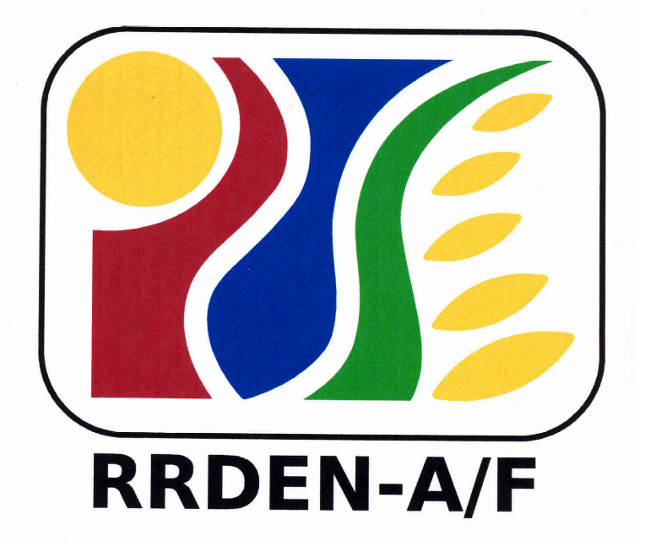
For Use of Evaluators
RRDEN and ViCARP
CY ___

Inter-Agency RDE Reviews
(Agriculture and Fisheries, Environment and Natural Resources)

Evaluation Instrument for Extension Program/Project
Overall Rating

Program/Project Title:
Agency/Office:
Staff Involved:
Duration (Specify Dates):

Evaluation Phase | Points Earned | Multiply Points Earned by | Product | Levels of Performance
- Project Presentation |  | .50
- Field Evaluation |  | .50
Overall Rating (Add Product A & B)

Evaluator’s Recommendation:
Recommendation | Comments
 Project for continuation
Project for suspension until compliance of recommendation/s
Project for termination
Project for completion
_Project for presentation at the Inter-agency Review/RDE Symposium as:
paper
poster
Additional Comments:

Evaluator (signature over printed name): ______________________________________________________ Date: _______________________

