Form 7B
Revised: 2015
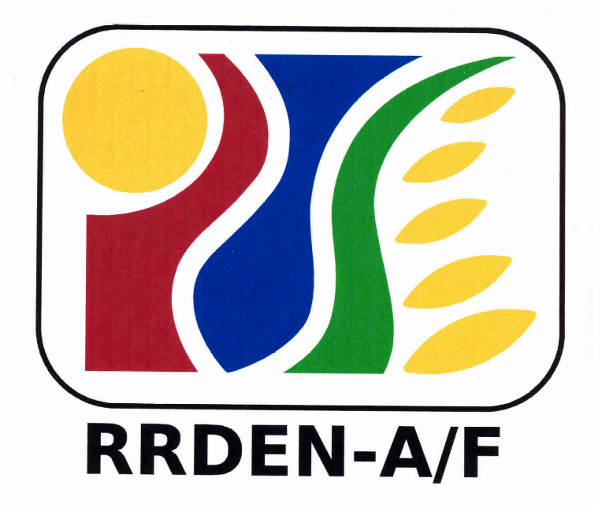
For Use of Evaluators
RRDEN and ViCARP
CY ___

Inter-Agency RDE Reviews
(Agriculture and Fisheries, Environment and Natural Resources)

Evaluation Instrument for Extension Service
Overall Rating

Agency/Office:
Staff Involved:
Evaluation Phase | Points Earned | Multiply Points Earned by | Product | Levels of Performance  (
- Project Presentation |  | .50
- Field Evaluation |  | .50
Overall Rating (Add Product A & B)

Evaluator’s Recommendation:
Recommendation | Comments
 Service for continuation
Service for suspension until compliance of recommendation/s
Service for termination
Service for completion
_Service for presentation at the Inter-agency Review/RDE Symposium as:
paper
poster

Evaluator (signature over printed name): ______________________________________________________ Date: _______________________

