Form 8
Revised: 2015
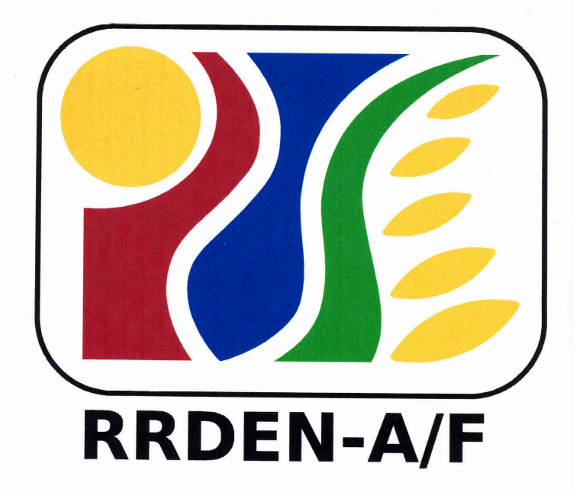
For Use of Evaluators
RRDEN and ViCARP
CY ___

Inter-Agency RDE Reviews
(Agriculture and Fisheries, Environment and Natural Resources)

Summary Evaluation for Extension Program/Project/Service

Form 7a. Summary for paper presentation1
Project Title |  | Rating
 |  | Paper Eval’r 1 | Paper Eval’r 2 | Paper Eval’r 3 | Paper Eval’r 4 | Paper Eval’r 5 | Total | Ave. | Rank
1.
2.
3.
4.
5.
6.
7.
8.
9.
10.
Certified correct by paper presentation evaluators:
Name & Signature of Evaluator | Name & Signature of Evaluator | Name & Signature of Evaluator |  |  |  | Name & Signature of Evaluator
Name & Signature of the Chairperson of the Paper Presentation Panel of Evaluators |  |  | Date:
¹ To be accomplished by the members of the panel of evaluators during the paper presentation.

Form72b. Summary of overall evaluation
Project Title | Overall Rating
Project Title | Field Eval’r 1² | Field Eval’r 2 | Field Eval’r 3 | Field Eval’r 4 | Field Eval’r 5 | Total | Ave. | Rank
1.
2.
3.
² Shall comprise of the average rating obtained by the project’s paper presentation multiplied by .50 and the field evaluation rating multiplied by .50 given by each field evaluator.

Evaluators’ recommendation
Recommendation (check box) | Comments
 Project/service for continuation
Project/service for suspension/termination/completion
_Project/service for presentation at the Inter-agency Review/RDE Symposium as:
paper
poster

Certified correct:
Name & signature of field evaluator | Name & signature of field evaluator
Name & signature of field evaluator | Name & signature of field evaluator
Name & signature of the chairperson of the panel of field evaluators
Date: __________________________

