Form 9
Revised: 2015
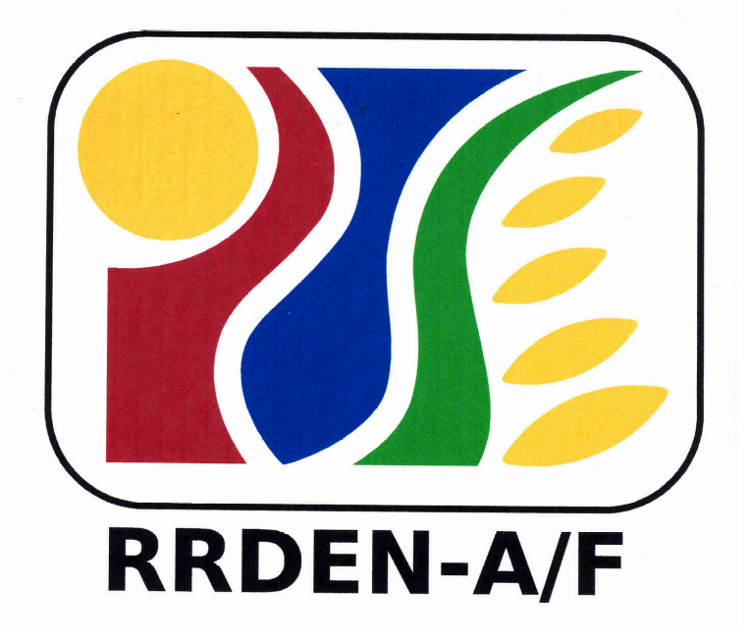
For Use of Evaluators
RRDEN and ViCARP
CY ____

Regional RDE Symposium
(Agriculture and Fisheries, Environment and Natural Resources)
SEARCH FOR OUTSTANDING PAPER

A. PROJECT/STUDY/ACTIVITY TITLE _______________________________________________________________
B. Presentor: ________________________________________________________________________________________
- PROGRAM/PROJECT LEADER(s)/PROPONENTS:________________________________________________________
- IMPLEMENTING AGENCY:
- FUNDING AGENCY : _________________ F. DURATION (Definite Date): __________ G. RMIS CODE: _____
- PROJECT/STUDY CLASSIFICATION: (Pls check)
____Basic ____Socio-econ ____Applied ____Development ____Extension

- EVALUATOR'S ANALYSIS/RECOMMENDATIONS/COMMENTS (Goals/Objectives, Methodology/Strategy of Implementation, Output, Impact/Sustainability)

- EVALUATOR’S RATING
A. RESEARCH AND DEVELOPMENT
CRITERIA/CATEGORY | RESEARCH |  |  | DEV’T | Rating
CRITERIA/CATEGORY | BASIC | SOCIO-ECON | APPLIED | DEV’T | Rating
Originality of the problem being investigated | 25%
Significance of the findings | 20%
Generation of new knowledge or innovativeness |  | 40% | 10%
Methodology (adequacy and innovativeness) | 30% | 35% | 20% | 25%
Potential socio-economic impacts |  | - | 25% | 30%
Potential environmental impacts |  |  | 20% | 20%
Presentation (written and oral) | 15% | 15% | 15% | 15%
Poster Presentation | 10% | 10% | 10% | 10%
TOTAL | 100% | 100% | 100% | 100%

- EXTENSION
PROGRAM/PROJECT |  | Rating | EXTENSION SERVICE |  | Rating
- Relevance | 10% |  | - Relevance | 10%
2. Operational Outcome | 55% |  | 2. Organizational Dynamics | 30%
2.1 Effectiveness (45%) |  |  | 2.1 Planning & Implement’ion Process (5%)
a. Social - (15%) |  |  | 2.2 Support Generated - (5%)
b. Economic – (10%) |  |  | 2.3 Personnel – (5%)
c. Environmental Effects – (10%) |  |  | 2.4 Facilities & Resources – (5%)
d. Quality of Interagency Collaboration – (10%) |  |  | - Linkages – (5%)  2.6 Awards & Recognition - (5%)
2.2 Efficiency (10%) |  |  | 3. Outcome/Impact of Services to the  clients/community | 35%
3. Internal Outcomes | 10% |  | 3.1 Social – (15%)
4. Presentation (written and oral) | 15% |  | 3.2 Economic – (10%)
5. Poster Presentation | 10% |  | 3.3 Environmental – (10%)
TOTAL | 100% |  | 4. Presentation (written and oral) | 15%
 |  |  | 5. Poster Presentation | 10%
 |  |  | TOTAL | 100%

Name & Signature of Evaluator

__________________
Date

